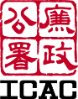 INDEPENDENT COMMISSION AGAINST CORRUPTION

CONTROLLING OFFICER’S
ENVIRONMENTAL REPORT 2024


Introduction

This Environmental Report accounts for the achievements made and measures taken by the Independent Commission Against Corruption (ICAC) in green management in 2024.

2. The ICAC is responsible for the following areas of work:

(a) enforce the law vigilantly and professionally in order to seek out and eradicate corruption wherever it exists;

(b) identify and eliminate opportunities for corruption in government bureaux/departments and public bodies, and advise the private sector on corruption prevention;

(c) promote public awareness of the evils of corruption, foster public confidence in and support for the work of the ICAC, encourage reporting of corruption, publicise to the international community Hong Kong’s effective anti-corruption regime as an important competitive advantage of Hong Kong, and consolidate the leading role of Hong Kong and the ICAC in the international anti-graft arena; and

(d) promote better public understanding of corruption and encourage target groups to take positive action.

3. As at 31 December 2024, the ICAC had an establishment of 1 549 accommodated in offices at different locations.


Environmental Commitment

4. The ICAC is committed to ensuring that our operations are conducted in an environmentally responsible manner. Whilst our daily businesses are primarily office-based, we are mindful that the way we work can have an impact on our environment. We therefore always strive to explore opportunities to integrate environmental protection principles into our daily operations.


Environmental Management Structure

5. To promote and sustain green practices, a dedicated Environmental Management Committee, headed by a Commission Green Manager and assisted by a team of Departmental Green Managers and Assistant Green Managers, has been in place since 1999 to review and monitor the ICAC’s environmental performance at each level of the organisation. The ICAC also receives feedback and suggestions on green management, and actively identifies new green initiatives. Through this Committee, we foster a green culture and promote green habits among our staff.


Green Measures and our Performance in 2024

6. The measures adopted and the results achieved in 2024 are set out below:
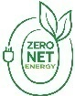
- Net-zero Electricity Generation

- We have maximised the available space at the rooftop of the ICAC Building and installed four solar photovoltaic panels to provide renewable energy to the building with all meters and related equipment in place in February 2024, generating renewable energy for on-site use since then.
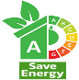
- Energy Saving and Green Buildings

- The Government has set a new 6% “Green Energy Target” in the 2019 Policy Address which seeks to further improve its use of energy for the period 2020-21 to 2024-25 under comparable operating conditions in 2018-19 as the baseline. By 2023-24, the ICAC has achieved energy saving of 4.3%. This was realised through various housekeeping measures on our air-conditioning, ventilation, lighting and lift systems, operation of office equipment and computer equipment; as well as replacement of over 2 500 fluorescent lights and 700 traditional spot lights and down lights by power-saving LED lights etc.


Air-conditioning

- We upgraded the Central Control and Monitoring System (CCMS) to enhance the energy efficiency of the air-conditioning system, and installed auto-timers for switching on and off the system. In addition, our CCMS has been integrated with the building’s access control system, enabling auto-switching off of air-conditioning in office areas.

- We have been sustaining effort to closely monitor the provision of air-conditioning in the ICAC Building and identify opportunity of energy saving, thereby largely reducing the air-conditioning supply to non-office areas of the ICAC Building from 100% to 30% and maintaining an optimal balance between the Government’s 25.5°C set-point policy and need of individual offices.


Lighting

- We reduced lighting in offices and common areas to the minimum required for illumination.

- We will continue to replace traditional spot lights and down lights with LED lights, with around 2 000 lights to be replaced in 2025.

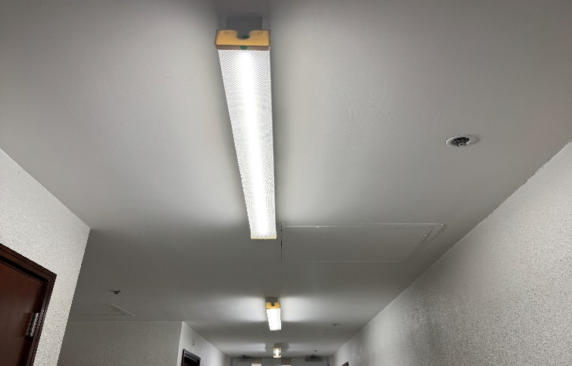

LED lights installed in ICAC Building

Lift

- We shut down passenger lifts after they remain idle to save energy and reduce their deterioration.

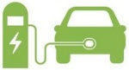
- Green Transport

- We replaced five Commission vehicles by electric vehicles in 2024 and planned to replace with another nine in the following year.

- We installed five medium electric vehicle chargers in the ICAC Building in 2024 and planned to install another nine in the following year.
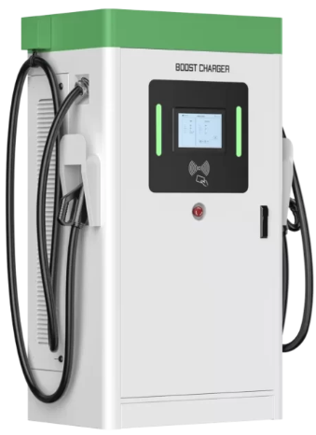
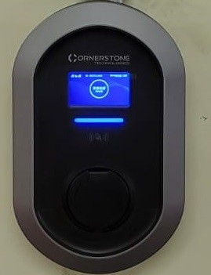

Electric vehicle chargers installed in the ICAC Building

- Waste Reduction and Recycling

(i) Waste minimisation

Paper

- We encourage the use of recycled paper. In 2024, all our paper consumed was recycled paper.

- We continue the practices of double-sided printing and photocopying, using blank side of used paper for drafting and printing, avoiding the use of fax leader pages, minimising the printing of hard copies, avoiding the use of envelopes for unclassified documents, and reusing loose minute jackets and envelopes.

- We have reduced printed copies of publications to the absolute minimum and will provide their electronic version by email or via the ICAC Website.

- We continue to leverage information technology to reduce paper consumption:

  - We use e-fax for unclassified documents as far as practicable, encourage internal communication by email, and post notices, announcements, circulars and regulations which require wide circulation on electronic bulletin boards.
  - We have computerised administrative processes such as application and approval of acting appointment and overtime work, event enrollment, collection of feedback, etc. and would continue with our efforts in this direction.

  - We distribute digital tablets to participants of selected in-house training courses and have started to use digital tablets in interview boards to reduce the need for printing.

  - We have developed a document sharing system for dissemination of documents within the Commission and a file sharing portal for the electronic transfer of document bundles.

- Our paper consumption has been reduced from 24 588 reams in 2021 to 14 193 in 2024 (-42%).


Plastic

- We have been using water purifying systems (reverse-osmosis water filtering and boiling machine) to minimise the need for carboy-sized or bottle-sized distilled water in all ICAC premises, except a few locations where the facilities disallowed.
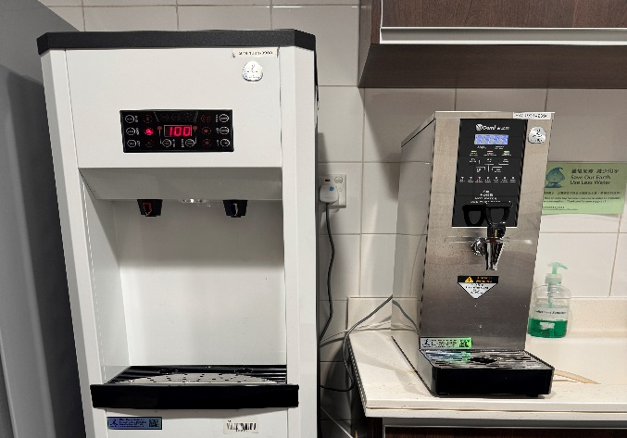

Water filtering and boiling machine installed in pantry of ICAC premises


Others

- We adopt the green practices and waste avoidance measures promulgated by the Government, where applicable. For example, we have stopped using corsages and would avoid exchanging gifts and souvenirs in official functions as far as practicable.

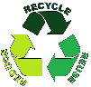
- Waste Recovery for Recycling and Reuse

- We use recycled laser printer cartridges for compatible printer models as far as practicable.

- We arrange collection of waste paper and used laser printer cartridges. We have also placed waste separation bins for collecting glass bottles, plastic, and metal recyclables in ICAC premises.

- Carbon Management 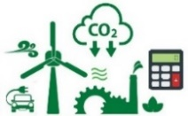

- We conduct carbon audit for ICAC premises annually. The total greenhouse gas emission was 7 856 tonnes of CO₂ equivalent in 2023-24. Through regular carbon audit, we are able to identify the major carbon emission sources and explore corresponding carbon reduction measures.

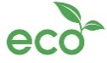
- Other Green Performance/ Housekeeping Measures

- Maintenance of a Clean Environment 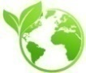

- We continue to provide an environmentally friendly and hygienic workplace for staff. Air-conditioning units are regularly cleaned to maintain their efficiency. Besides, periodic indoor air quality checks are conducted in office premises. The ICAC Building complies with the Excellent Class of Indoor Air Quality Objectives under the Indoor Air Quality Certification Scheme.


- Green Procurement

- Environmental considerations such as green specifications for common products and green guidelines stipulated in the prevailing Environment and Ecology Bureau Circular Memorandum are taken into account when procuring goods and services.

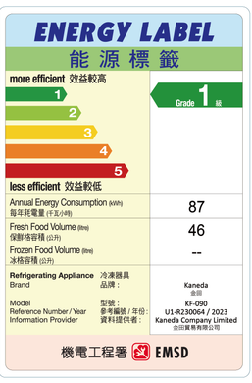
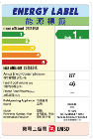
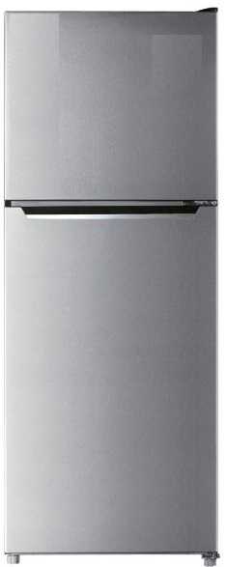

Procurement of energy-saving refrigerator

- We minimise the use of products which are not environmentally friendly and procure green products including recycled paper, refillable ball pens, clutch pencils, non-chlorinated correction fluid and recycled laser printer cartridges. Other green items include biodegradable plastic garbage bags, energy-saving lights, and energy-efficient office equipment and electrical appliances.

- Green guidelines on waste recovery and recycling, use of environmentally friendly materials, and water and energy saving are built into cleansing contracts so as to give due consideration to environmental factors in the delivery of services.

- House-keeping Measures 

- We arrange regular checking to ensure lights, air-conditioners and equipment in common facilities are switched off outside office hours.

- We issue biannual notices to all computer users to remind them to switch off computer equipment after office hours.

- We have scheduled automatic shutdown of computer workstations every night after a period of user inactivity.


- Water Conservation

- We are using auto-sensitised water taps and auto-sensitised (timer-based) urinal flushing system to save water where applicable.

- We have reduced the flow of water tap in pantries and toilets of the ICAC Building to save water.



- Staff Participation

- We participated in “Green Low Carbon Day 2024” to raise funds for green related projects supported by The Community Chest, and to encourage staff to adopt a low-carbon lifestyle.

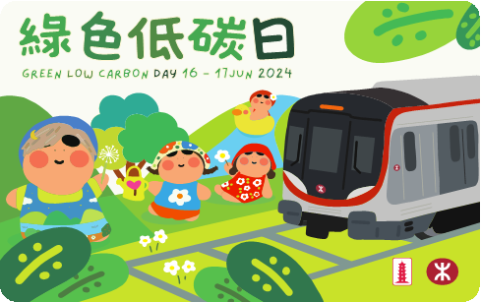
Green Low Carbon Day 2024

- We participated in the Earth Hour 2024 by switching off non-essential lights for an hour in the ICAC Building.

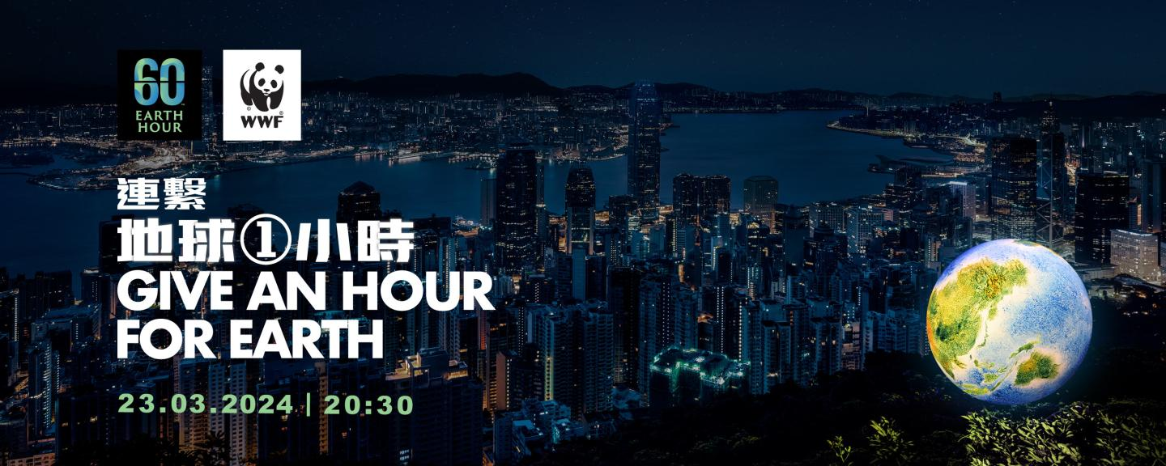
Earth Hour 2024

- We maintain green tips and consumption statistics on electricity, paper and envelopes, toilet paper and recycled laser printer cartridges on our Environmental Management Bulletin Board to let staff know the consumption pattern and the need to conserve the environment.

- The caterer of the ICAC Staff Mess provides vegetarian menu in addition to regular ones and caterer would prepare food in smaller portions according to demand to reduce wastage.

- We continue to promote green messages and introduce the work of the Environmental Management Committee to ICAC new recruits at the induction course.


Way Forward

- We shall continue to step up our efforts in promoting green awareness by education and green activities to foster an environmentally friendly culture in the ICAC. We shall strive to adhere to the green procurement policy and take environmental considerations into account when procuring goods and services. All in all, green management has become an integral part of office management and environmental protection is an obligation of everyone in the ICAC.


Feedback and Suggestions

8. We remain open and active in identifying available means to achieve our green management objectives. If you have any feedback or suggestions, please e-mail us at general@icac.org.hk.

Independent Commission Against Corruption
September 2025

