Reports of
ICAC Advisory Committees

2025

Advisory Committee on Corruption

ADVISORY COMMITTEE ON CORRUPTION

ANNUAL REPORT 2025
TO THE CHIEF EXECUTIVE

The Chief Executive the Honourable
Mr John LEE Ka-chiu,

TERMS OF REFERENCE AND MEMBERSHIP
The Advisory Committee on Corruption (ACOC) is the principal advisory body of the Independent Commission Against Corruption (ICAC). It oversees ICAC’s overall strategies and its operational, staffing and administrative policies. The terms of reference and membership of the ACOC in 2025 are set out at Annexes A and B respectively. The Chairmen of the Operations Review Committee, the Corruption Prevention Advisory Committee, and the Citizens Advisory Committee on Community Relations are among the ex-officio members serving the ACOC. Mr SIU Chor-kee and Ms Cecilia LEE Sau-wai retired in 2025, while Ms Mary HUEN Wai-yi and Mr David LIAO Yi-chien joined the Committee as new members in 2026.

WORK OF THE COMMITTEE
During 2025, the ACOC held three meetings to review the corruption situation in Hong Kong, scrutinise the work reports presented by the heads of the three departments of the ICAC, i.e. Operations Department, Corruption Prevention Department, and Community Relations Department, and provide advice. The Committee was pleased to note that the ICAC remained steadfast and committed to fulfilling its anti‑corruption mission through the “three‑pronged strategy” encompassing law enforcement, prevention and education, and proactively fostered international cooperation against corruption, yielding encouraging results.

OVERVIEW OF THE WORK
The ACOC noted from the ICAC’s reports that Hong Kong remained to be a clean society with a very low level of corruption in 2025. The overall number of corruption complaints dropped compared to the previous year, with decreases recorded in cases involving government departments, public bodies and the private sector, while the proportions among these sectors were similar to the previous year. Meanwhile, public confidence in the ICAC remains strong, with about 70% of the complainants identifying themselves when reporting corruption.

In 2025, the ICAC received a total of 1 780 corruption complaints (excluding election complaints), representing a decrease by 14% (278 complaints) when compared to 2024. Regarding the public sector, the civil service remained clean and honest, despite isolated cases of civil servants being investigated or prosecuted for corruption offences. The ACOC was also aware that the ICAC completed 67 corruption prevention studies for government departments and public bodies, as a sustained effort to reduce corruption risks in public administration.

As for the private sector, the ICAC continued to adopt a holistic strategy to safeguard Hong Kong’s clean and fair business environment and strengthen the corruption prevention capabilities of different industries. The ACOC was particularly concerned about corruption in the building management and maintenance subsector, the finance and insurance subsector, and the construction subsector which recorded the most complaints. In June 2025, the ICAC took the lead in hosting the first-ever Building Management Summit in Hong Kong, gathering over 300 participants from relevant government departments, regulatory bodies, professional organisations, 18 District Councils, owners’ corporation representatives, property management practitioners as well as flat owners. However, the fire at Wang Fuk Court in Tai Po in late November revealed deep-seated issues in building management and maintenance. The ICAC immediately set up a task force the day after the fire to launch a full investigation into the possible corruption in the grand renovation project of Wang Fuk Court and take enforcement actions. The Government also established an Independent Committee on 12 December to examine the cause of the fire and related issues. I have been appointed as a member of the Independent Committee. Upon my request, approval was given by the Chief Executive to suspend my position as Chairman of the ACOC until the completion of work of the Independent Committee so that I could dedicate myself more fully to the Committee’s work.

The ACOC is confident that the ICAC will fully cooperate with and support the Independent Committee’s work and continue to adopt its “three-pronged” and early intervention strategies to proactively take enforcement actions and remind flat owners of corruption risks in contract awards with a view to intercepting potential illegal activities. The ICAC will also work closely with the relevant government departments and regulatory bodies to combat corruption and illegal activities in building renovation projects.

As regards the finance and insurance subsector, the ICAC signed Memoranda of Understanding (MoU) with several regulatory bodies in recent years to jointly combat corruption and other illegal activities. Regarding the construction subsector, the ICAC took robust enforcement actions and reviewed work processes to plug corruption loopholes. In May, the ICAC mounted an operation codenamed “War Drum”, which uncovered corruption and fraud in relation to steel reinforcement works in a private residential project. It followed with the provision of a series of corruption prevention recommendations to the Buildings Department in order to improve works supervision.

Furthermore, the ACOC appreciated the ICAC’s innovative strategies under the leadership of the Commissioner. After the opening of the Café 1974 at the ICAC Building in November 2024, the ICAC also completed a comprehensive revamp of its exhibition hall in May 2025, incorporating innovative technological elements to transform Hong Kong’s integrity culture into a landmark attraction for the public and visitors. The ACOC was also pleased to note ICAC’s effort in using multimedia to disseminate anti-corruption messages. During the year, the ICAC’s in-house micro-film series such as “Coffee War” and animations produced by artificial intelligence for the Legislative Council General Election all attracted wide attention and significantly enhanced publicity impact. As for the youth work, the ICAC continued to nurture young people through “ICAC ELITE Youth Leadership Programme”, “ICAC Ambassador Programme”, and “iTeen Leadership Programme for Senior Secondary School Students” to uphold integrity and rule of law, while also providing opportunities for them to learn about our nation and broaden their global vision.

Support Clean Elections
The ACOC endorsed ICAC’s “all-embracing” strategy, with prevention and intervention to strengthen stakeholders’ understanding of the electoral laws, as well as resolute enforcement to crack down on acts of election manipulation and sabotage. This approach was effective in ensuring that the Election Committee Subsector By-election in September and the eighth Legislative Council General Election in December were conducted in a fair, open and honest manner. On the polling day for the Legislative Council General Election, the ICAC fully mobilised over 1 300 officers to station at polling stations across the territory and all regional offices to swiftly handle enquiries and complaints. Alongside safeguarding a clean election, ICAC officers also fulfilled their civic duty and obligation as government officers by casting their votes. This exemplified their commitment to upholding the Basic Law, pledge of allegiance to the Hong Kong Special Administrative Region and the principles of the Civil Service Code, exhibiting the excellent qualities of ICAC officers. The ACOC considered all these highly commendable.

Fostering International Exchange and Collaboration
The ACOC welcomed ICAC’s tremendous efforts to enhance Hong Kong’s status in the global anti-corruption arena. Moreover, the ICAC continued to fortify the anti-graft tripartite partnership formed with the Hong Kong International Academy Against Corruption (HKIAAC) and the International Association of Anti-Corruption Authorities (IAACA), giving full play to its synergy to strengthen international collaboration with remarkable results. The ICAC leveraged Hong Kong’s unique advantage under the “One Country, Two Systems” to align with national anti‑corruption initiatives in the 15th Five‑Year Plan. Acting as a “super connector,” the ICAC promoted the culture of integrity and probity, and shared Hong Kong’s graft-fighting experience with the international community, making greater contributions to both national and global anti-corruption cause.

In 2025, the ICAC has entered into MoU with anti-corruption authorities (ACAs) of more “Belt and Road” countries, including the United Arab Emirates, Hungary and Greece, further broadening the international graft-fighting network. During the year, the Commissioner led delegations to visit countries in the Middle East and the Association of Southeast Asian Nations, while high-level delegations from over 10 countries visited the ICAC. Besides, the ICAC pioneered to partner with other law enforcement agencies in Hong Kong such as the Hong Kong Police Force and the Hong Kong Customs and Excise Department to share their experience in joining hands to prevent and combat corruption and malpractices, and had effectively explored diverse modes of collaboration.

As the IAACA President, the Commissioner attended the G20 Anti‑Corruption Working Group Meeting for the first time in South Africa and forged strategic partnerships with overseas ACAs. In December 2025, IAACA convened its first General Meeting and Annual Conference in Doha, Qatar, to chart the path for fostering international cooperation among ACAs globally. Since the adoption of the Hong Kong Declaration on Strengthening International Cooperation in Preventing and Fighting Corruption in May 2024, ACAs worldwide have actively implemented the initiatives, yielding fruitful outcomes.

The ICAC further strengthened its partnership with the United Nations Office on Drugs and Crime (UNODC) following the signing of MoU in May 2024. This collaboration advanced global projects, including the promotion of artificial intelligence and technology in investigations for tackling increasingly complex corruption cases globally, and the joint development of the Guide on Corruption Risk Management in Prison Systems. In addition, the ICAC supports the development of the Global Operational Network of Anti-Corruption Law Enforcement Agencies under the auspices of UNODC, contributing to the strengthening of global collaboration in law enforcement and promotion of exchange.

The ACOC also oversees the work of the HKIAAC regarding international training. During the year, the HKIAAC organised 20 international training programmes in Hong Kong or overseas for ACAs from various countries, including Brazil, Brunei Darussalam, Cambodia, Hungary, Kazakhstan, Saudi Arabia, Sri Lanka, Thailand, and the United Arab Emirates, benefitting about 1 800 participants. For major international courses conducted in Hong Kong, visits to the Mainland were arranged to cities including Shenzhen of Guangdong Province, Wuhan of Hubei Province, and Qingdao of Shandong Province. Such visits enabled participants to gain an accurate understanding of the social development as well as anti-corruption achievements of our country and Hong Kong. In addition, the HKIAAC conducted 11 tailored local professional training programmes for different industries and sectors, which were participated by over 800 managerial personnel from various sectors.

International Recognition
In 2025, Hong Kong continued to be rated as one of the world’s cleanest places by international ranking institutions. In Transparency International’s Corruption Perceptions Index 2025, Hong Kong ranked 12th out of 182 countries/territories, five places up from the previous year’s ranking. This was the most notable rise since the index was launched in 1995, and also earned Hong Kong the second place in Asia. According to the World Justice Project’s Rule of Law Index 2025, Hong Kong secured the ninth place among 143 jurisdictions under the indicator “Absence of Corruption.” In addition, the International Institute for Management Development’s World Competitiveness Yearbook 2025 ranked Hong Kong the fourth position among 69 economies under the indicator “bribery and corruption do not exist.” These achievements are clear evidence of not only the recognition of ICAC’s anti-corruption work, but also the robust rule of law and anti-corruption regime of Hong Kong.

Corporate Governance
The ICAC has continued to attain remarkable achievements, demonstrating the professionalism of its team and good governance. The ACOC specifically noticed that the ICAC had included national security as an important component in its internal training. Through national studies programmes with sharing sessions, thematic seminars, online courses, etc, the ICAC ensured that their staff would have an accurate understanding of the national development strategies, national security perspective, and holistic views of our country, thereby further reinforcing their sense of mission and responsibility.

The ACOC will continue to rigorously monitor the ICAC’s work and provide timely and appropriate advice to ensure its accountability. Last year, the ACOC reviewed the ICAC’s estimates of expenditure, personnel management matters (including disciplinary and conduct issues) and annual report, all of which were handled properly.

Press Briefing

On 3 March 2025, together with the Chairmen of the other three ICAC advisory committees, I conducted a briefing session with the media on our work in 2024, where we shared with the media our views and comments on the work of the ICAC and answered questions from the press.

APPRECIATION
Last but not least, I would like to express my heartfelt gratitude to all members of the ACOC for their contributions, which ensured that the Committee was able to discharge its duties effectively. I also wish to thank ICAC officials for their steadfast commitment in fulfilling the mission of combating corruption and upholding integrity, as well as for reporting to the ACOC and responding thoroughly to members’ questions. In reviewing the ICAC’s work in 2025, the ACOC gives its full recognition and support. The ACOC firmly believes that, as the ICAC embarks on its next 50 years, it will continue to combat corruption with dedication and without fear or favour, foster global cooperation in integrity building, and through continuous innovation and tireless effort, make even greater contributions to the anti‑corruption cause in Hong Kong, the country and the world.
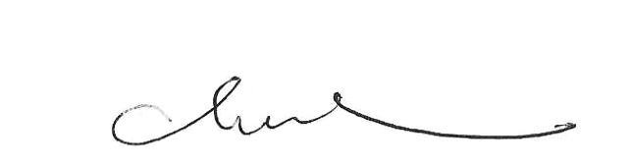
CHAN Kin-por, GBS, JP
Chairman
Advisory Committee on Corruption
Annex A ADVISORY COMMITTEE ON CORRUPTION
TERMS OF REFERENCE (as at 31 December 2025)

- To advise the Commissioner of the Independent Commission Against Corruption on any aspect of the problem of corruption in Hong Kong, and, to this end:

  - to keep the operational, staffing and administrative policies of the Commission under review;

  - to advise on action being considered by the Commissioner under section 8(2) of the Independent Commission Against Corruption Ordinance;

  - to receive reports by the Commissioner on disciplinary action taken;

  - to consider the annual estimates of expenditure of the Commission;

  - to scrutinise the annual report of the Commission before its submission to the Chief Executive; and

  - to submit an annual report to the Chief Executive on the work of the Committee.

- To draw to the Chief Executive’s attention, as it considers necessary, any aspect of the work of the Commission or any problem encountered by it.

Annex B ADVISORY COMMITTEE ON CORRUPTION
MEMBERSHIP (as at 31 December 2025)
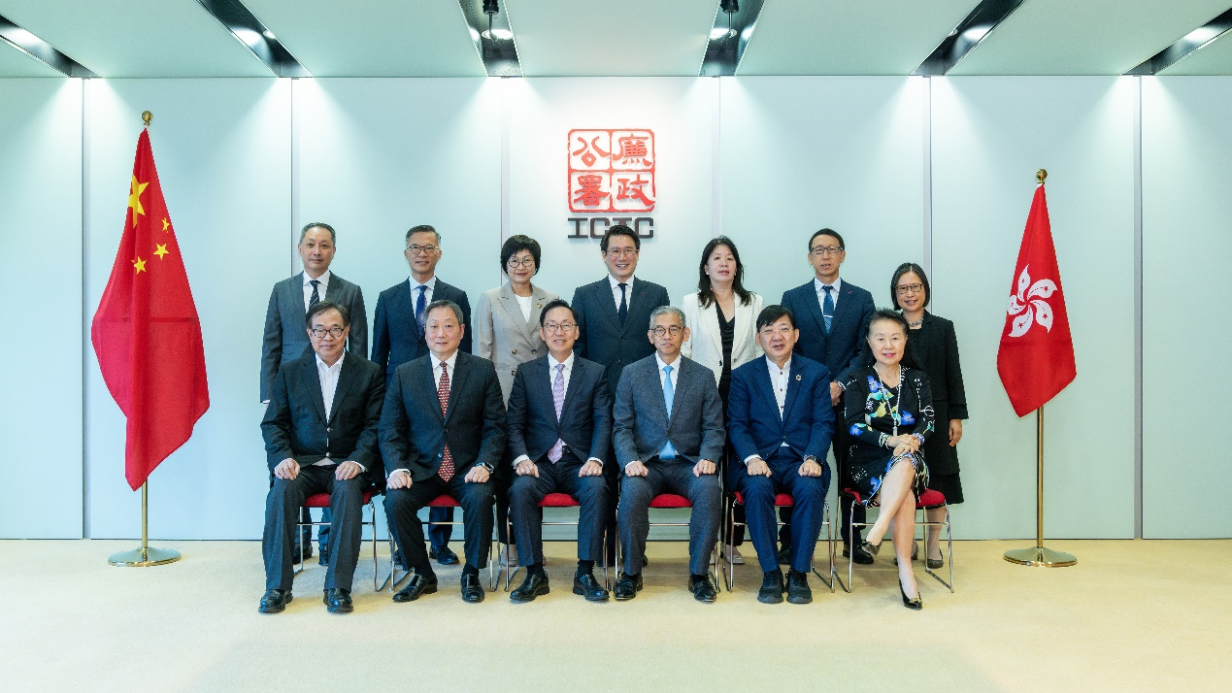
The Hon Chan Kin Por, GBS, JP | (Chairman)
Ms AU King-chi, GBS, JP
The Hon Chan Yung, SBS, JP
Mr Victor LAM Hoi-cheung, MH, JP
Ms Cecilia LEE Sau-wai, JP
The Hon Dr Lo Wai-kwok, GBS, MH, JP
Chairman of the Operations Review Committee | (ex officio)
Chairman of the Corruption Prevention Advisory Committee | (ex officio)
Chairman of the Citizens Advisory Committee on Community Relations | (ex officio)
Director of Administration | (ex officio)
Commissioner, Independent Commission Against Corruption | (ex officio)
Deputy Commissioner and Head of Operations, Independent Commission Against Corruption | (ex officio)

Operations Review
Committee

OPERATIONS REVIEW COMMITTEE

ANNUAL REPORT 2025
TO THE CHIEF EXECUTIVE

The Chief Executive the Honourable
Mr John LEE Ka-chiu,

TERMS OF REFERENCE AND MEMBERSHIP
The Operations Review Committee, comprising 13 non-official members and four official members, oversees the work of the Operations Department of the Independent Commission Against Corruption (ICAC). Its terms of reference and membership are at Annexes A and B respectively. At the end of 2025, Dr Aron Hari HARILELA retired from the Committee after six years of service, while Ms KUOK Hui-kwong joined the Committee in 2026.

WORK OF THE COMMITTEE
During the eight meetings held in 2025, the Committee deliberated the reports prepared by the Operations Department, with detailed explanation provided by responsible senior officers of the ICAC concerning the processes in investigation, enforcement, search and prosecution. The reports and updates from the Operations Department covered current major investigations, cases prosecuted at court, ICAC investigations spanning over a year, cases involving persons who had been on ICAC bail for over six months, as well as 14 completed major investigations. Each member actively raised questions during the meetings to ensure that all cases handled by the Operations Department were dealt with in accordance with the law and utmost standard of professionalism, and where necessary, legal advice from the Department of Justice (DoJ) would be sought. The ICAC would not curtail investigations that have not been reviewed by the Committee. The Committee also noted that no search warrants had been issued by the Commissioner pursuant to section 17 of the Prevention of Bribery Ordinance (Cap 201).

A Subcommittee with three non-official members sitting in rotation convened on eight separate occasions to consider and advise on 1 570 completed minor investigations and 341 non-pursuable complaints of corruption. Findings of the Subcommittee were reported to the Committee for endorsement.

The Head of Operations attended the Committee meetings to brief members on the work of the Operations Department, corruption statistics and trends and other issues of interest. The Committee also considered the Annual Report on Corruption and Malpractice in the Government 2024 submitted by the Operations Department which identified areas susceptible to corruption and malpractice in the Government.

GENERAL CORRUPTION SCENE
Based on the observations of the Committee, the corruption situation in Hong Kong continues to be well under control. The civil service and public bodies in Hong Kong remain clean and honest, while a corruption-free and level-playing field is maintained for private enterprises. In 2025, a total of 1 780 corruption complaints (excluding election complaints) were received, 1 449 of which were pursuable reports, representing a year-on-year decrease of 14% and 11% respectively. A total of 95 cases were referred to the ICAC for action by various government bureaux and departments, accounting for 5% of the overall complaints. Overall, around 70% of the corruption complaints concerned the private sector, 24% involved government departments and 6% public bodies, similar to the proportions in 2024.

Corruption is a highly insidious crime which is difficult to detect, given that the offeror and acceptor of a bribe are both beneficiaries of the act. Such characteristic has posed huge challenges to the mission of bringing the corrupt to justice. Through the reports of various corruption investigations, the Committee has a clear understanding of the challenges faced by investigators. With the advancement of technology and globalisation, the modus operandi of criminals is becoming more sophisticated. In spite of these, the Committee appreciates that the Operations Department has maintained professionalism and risen to challenges ahead by pursuing each and every corruption case vigilantly with perseverance. In 2025, 175 persons involved in 79 cases were prosecuted. In the same year, 171 persons were convicted. The person-based and case-based conviction rates were 81% and 90% respectively, while 34 persons were formally cautioned for minor breaches of offences upon legal advice from the DoJ.

The Committee notes that public support for the ICAC’s anti-corruption work remains strong, with 71% of the complainants identifying themselves when reporting corruption, which is similar to the proportions recorded in previous years.

CORRUPTION IN THE GOVERNMENT SECTOR
In 2025, a total of 426 corruption complaints concerning staff of government bureaux and departments were received, 325 of which were pursuable reports, representing a year-on-year decrease of 11% and 5% respectively.

In 2025, upon comprehensive review of the investigation reports and recommendations submitted by the Operations Department, the Committee endorsed the referral of 42 cases involving 87 government servants to the relevant bureaux and departments for consideration of disciplinary and/or administrative action. Such referrals mainly involved misuse of authority and acceptance of unauthorised loans. The Committee fully appreciates that the citizens of Hong Kong have always held great expectations of the integrity and accountability of the civil service. In fact, a clean civil service is the bedrock of maintaining public confidence in the Government and the prosperity of society. During the year, eight government servants were prosecuted for corruption or other illicit acts, while 19 others were formally cautioned. That said, the Committee is confident that the civil service remains clean and trustworthy.

The ICAC has taken prompt and vigorous action against isolated cases of corruption and malpractice. A Senior Engineer of the Electrical and Mechanical Services Department who handled minor works contracts was charged with maintaining a standard of living above that which was commensurate with his official emoluments, misconduct in public office and other related offences. The case was extremely challenging and had undergone seven years of investigation and prosecution procedures. Upon his guilty plea in 2025, the Senior Engineer was sentenced to five years and three months’ imprisonment. In another case, an Assistant Taxation Officer of the Inland Revenue Department (IRD) was charged for soliciting and accepting advantages from four taxpayers for assisting them to pay less tax and track debtors for debt collection. The IRD Officer also conspired with a Foreman of the Food and Environmental Hygiene Department (FEHD) for conducting an unauthorised search in the IRD’s computer system for information relating to an FEHD complainant. They were charged for accepting advantages and misconduct in public office. The cases demonstrate that the ICAC does not tolerate any corruption or improper conduct of government servants.

The Committee is confident that the Operations Department will continue to impartially investigate every corruption complaint in accordance with the law, and strive to improve governance by forging continuous collaboration with government bureaux and departments to ensure the integrity and probity required of government servants. The Committee notes that full assistance was rendered to the ICAC by the relevant departments during the investigations.

CORRUPTION CONCERNING PUBLIC BODIES
In 2025, a total of 116 corruption complaints relating to public bodies were received, 87 of which were pursuable reports, representing a year-on-year decrease of 17% and 20% respectively. The public bodies attracting most complaints were the Hospital Authority, MTR Corporation Limited and the University of Hong Kong (20, 10 and 7 complaints respectively), which together accounted for 32% of the total complaints relating to public bodies.

CORRUPTION IN THE PRIVATE SECTOR
In 2025, a total of 1 238 corruption complaints concerning the private sector were received, 1 037 of which were pursuable complaints, representing a year-on-year decrease of 14% and 12% respectively. The top three subsectors attracting most complaints were Building Management and Maintenance (down from 509 to 467 complaints), Finance and Insurance (up from 140 to 144 complaints) and Construction Industry (down from 190 to 140 complaints).

In late November 2025, the fire at Wang Fuk Court in Tai Po caused heavy casualties. In view of the immense public interest involved, the ICAC set up a task force the day after the fire to launch a full investigation into potential corruption in the grand renovation project of Wang Fuk Court. The task force swiftly took enforcement actions with the arrest of various individuals involved and the investigation is ongoing with all due effort. Since the establishment of the task force, the ICAC has provided detailed progress reports on the case at each Committee meeting.

Building Management and Maintenance are closely related to the daily lives of the citizens. In recent years, the subsector has accounted for over 30% of corruption complaints in the private sector. The Operations Department maintains a dedicated team of approximately 50 odd investigating officers tasked with combating corruption in the subsector. In addition to traditional investigation, evidence collection and prosecution, the ICAC also adopts early intervention actions and proactive strategies to alert property owners about the risks of corruption in contract awarding, so as to nip in the bud potential corruption and related illegal activities. In fact, the ICAC has actively conducted multiple large-scale enforcement operations in recent years to target corrupt individuals in the industry, with some operations carried out jointly with the Competition Commission. The ICAC has also widely publicised these real cases through the media to raise public awareness. The Committee acknowledges that the issues of Building Management and Maintenance are highly complex, requiring coordinated efforts of the stakeholders from the Government and various sectors of the society. The Committee is confident that the ICAC will continue to strive to implement effective strategies, take robust enforcement actions to achieve a deterrent effect, and further strengthen related prevention and education initiatives to enhance the industry’s awareness in anti-corruption and reinforce integrity management.

Corruption in the Construction Industry also affects the stable living of the citizens. During an operation codenamed “War Drum” mounted in mid-2025, the ICAC uncovered corruption and fraudulent claims of inspections at a construction site of a residential project in Kwun Tong and arrested 10 individuals. They were alleged to have bribed the staff members of the main contractor and consultancy company in exchange for lax supervision of steel reinforcement works carried out by subcontractors, as well as conniving at works deviated from the building plans. In view of the case, the ICAC has further strengthened relevant prevention and education initiatives and conducted reviews on the relevant construction and site supervision procedures to eliminate corruption loopholes.

The Committee notices that the ICAC has maintained close partnership and separately signed memoranda of understanding with various financial regulators to jointly combat corruption and irregularities in the financial market, so as to consolidate Hong Kong’s status as an international financial centre. During an operation codenamed “Arrow Shower” mounted in March 2025, the ICAC arrested 22 individuals, including 18 employees of local banks. Allegedly, they accepted bribes totalling $2 million for assisting a mortgage loan referral intermediary to use false income proof documents or referral information to mislead banks into approving mortgage loans and releasing referral fees in over 200 applications. Later in October 2025, the ICAC and the Hong Kong Police Force conducted a joint operation codenamed “Momentum” against corruption-facilitated fraudulent loan applications for the Special 100% Loan Guarantee as well as the 80% and 90% Guarantee Products under the Small and Medium-sized Enterprises Financing Guarantee Scheme. The two agencies arrested a total of 32 individuals in connection with fraudulent loan applications amounting to $140 million.

The Committee is also pleased to notice that in November 2025, the Court of Final Appeal unanimously allowed the appeal of the DoJ and restored the convictions of four senior executives of a listed company, who were charged with conspiracy to defraud over bonds placement of the listed company. This case underwent an eight-year protracted journey of investigation, trial and appeal, with the process fully reflecting the close collaboration, commitment to the rule of law, and relentless dedication of the staff of the ICAC and the DoJ, as well as their determination to safeguard the integrity and fairness of the financial market in Hong Kong.
ELECTIONS
The Election Committee Subsector By-elections (ECSS By-elections) and the Legislative Council General Election (LCGE) were successfully held in September and December 2025 respectively. On the polling day of the LCGE, the ICAC mobilised all staff of over 1 300. Apart from stationing at over 600 polling stations to handle election related inquiries and complaints from the public, the ICAC staff also monitored the voting and counting processes. During the election period, there were posts on social media platforms that incited others not to vote or to cast invalid votes, contravening Section 27A of the Elections (Corrupt and Illegal Conduct) Ordinance. The Committee commends the ICAC in taking resolute enforcement actions to crack down on any illegal acts attempting to manipulate or sabotage the election.

As at the end of 2025, the ICAC received one election complaint related to the ECSS By-elections and 24 election complaints related to the LCGE. As regards the Section 27A offence, the ICAC arrested 13 individuals who were suspected of disseminating or sharing online information that incited others not to vote or to cast invalid votes and attempted to interfere with and sabotage the election. Three of the arrestees were charged, while three others who left Hong Kong are wanted by the ICAC.

CONCLUSION AND THE WAY FORWARD
Established in 1974, the ICAC has operated for over 50 years. With the support of the Government and the community, a culture of integrity has taken root in Hong Kong. As a law enforcement agency in which Hong Kong citizens take pride, the ICAC has dedicated over half a century to combating corruption and promoting integrity, transforming Hong Kong into one of the world’s cleanest cities and establishing it as a globally renowned hub of integrity. The Committee is assured that the Operations Department will continue its graft-fighting mission relentlessly without fear or favour to consolidate Hong Kong’s rule of law foundation and its reputation as a corruption-free city.

APPRECIATION
Last but not least, I would like to express my sincere gratitude to each member of the Committee, who always stood by my side. Despite the heavy workload, they diligently fulfilled their responsibilities in overseeing the work of the Operations Department with dedication and contribution in reviewing each and every case in a stringent and objective manner, as well as sharing of valuable insights. The Committee also takes the opportunity to commend the officers of the Operations Department for upholding the resolute spirit of the ICAC, consistently demonstrating professionalism and unwavering commitment in fulfilling their anti-corruption mission.

Bernard Charnwut CHAN, GBM, GBS, JP
Chairman
Operations Review Committee

Annex A OPERATIONS REVIEW COMMITTEE
TERMS OF REFERENCE (as at 31 December 2025)

- To receive from the Commissioner of the Independent Commission Against Corruption information about all complaints of corruption made to the Commission and the manner in which the Commission is dealing with them.

- To receive from the Commissioner progress reports on all investigations lasting over a year or requiring substantial resources.

- To receive from the Commissioner reports on the number of, and justifications for, search warrants authorised by the Commissioner, and explanations as to the need for urgency, as soon afterwards as practicable.

- To receive from the Commissioner reports on all cases where suspects have been bailed by the Commission for more than six months.

- To receive from the Commissioner reports on the investigations the Commission has completed and to advise on how those cases that on legal advice are not being subject to prosecution or caution, should be pursued.

- To receive from the Commissioner reports on the results of prosecutions of offences within the Commission’s jurisdiction and of any subsequent appeals.

- To advise the Commissioner on what information revealed by investigations into offences within its jurisdiction shall be passed to government departments or public bodies, or other organisations and individuals, or, where in exceptional cases, it has been necessary to pass such information in advance of a Committee meeting, to review such action at the first meeting thereafter.

- To advise on such other matters as the Commissioner may refer to the Committee or on which the Committee may wish to advise.

- To draw to the Chief Executive’s attention any aspect of the work of the Operations Department or any problems encountered by the Committee.

- To submit annual reports to the Chief Executive which should be published.

Annex B OPERATIONS REVIEW COMMITTEE
MEMBERSHIP (as at 31 December 2025)
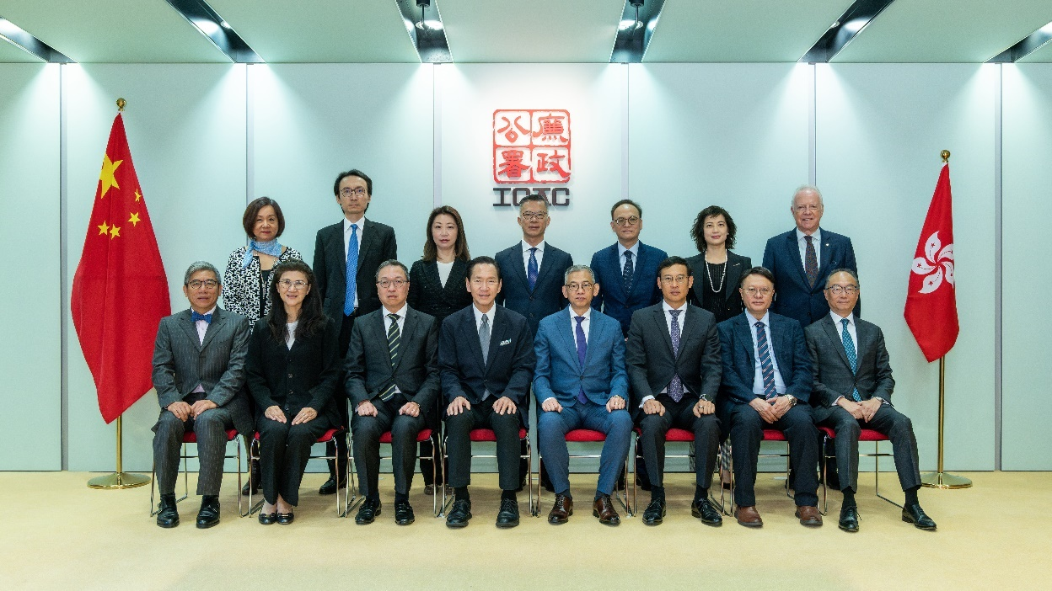
The Hon Bernard Charnwut CHAN, GBM, GBS, JP | (Chairman)
Ms Teresa AU Pui-yee, MH
Mr Samuel CHAN Ka-yan, BBS, JP
Ms Clara CHAN Yuen-shan, MH, JP
Mr Robert David DORFMAN
Dr Aron Hari HARILELA, BBS, JP
Prof David HUI Shu-cheong, BBS, JP
The Hon Carmen KAN Wai-mun, JP
Mr Johnson KONG Chi-how
Ms Vivien LAU Man-yee
Mr Felix LI Kwok-hing
Prof LI Pang-kwong, BBS, JP
Ms Melissa Kaye PANG, BBS, MH, JP
Secretary for Justice (or representative) | (ex officio)
Commissioner of Police (or representative) | (ex officio)
Director of Administration | (ex officio)
Commissioner, Independent Commission Against Corruption | (ex officio)

Corruption Prevention Advisory Committee

CORRUPTION PREVENTION ADVISORY COMMITTEE

ANNUAL REPORT 2025
TO THE CHIEF EXECUTIVE

The Chief Executive the Honourable
Mr John LEE Ka-chiu,

TERMS OF REFERENCE AND MEMBERSHIP
The Corruption Prevention Advisory Committee (CPAC), comprising 12 non-official and 3 official members, advises the Commissioner of the Independent Commission Against Corruption (ICAC) on the work of the Corruption Prevention Department (CPD). Its terms of reference and membership are at Annexes A and B respectively. This year, Ms Cindi HUI Ming-ming has succeeded Mr Winson WOO Lap-kee as member of the CPAC. Through six subcommittees, each comprising two non-official members, the CPAC advises on the work and review subjects of the six Assignment Groups of CPD and their priorities.

WORK OF THE COMMITTEE
During the year, the CPAC met on six occasions, and considered 67 assignment studies presented by CPD. These studies involved mainly the systems and functions of government bureaux/departments (B/Ds) and public bodies (PBs), as well as researches conducted on the corruption prevention systems of various industries or areas. They were scrutinised by the CPAC to ensure that the recommendations made by CPD were effective and practical to mitigate the corruption risks identified. A list of the assignment studies endorsed by the CPAC is at Annex C. After the issue of studies, the ICAC followed up closely with the B/Ds and organisations concerned on their implementation of the corruption prevention recommendations.

The CPAC notes that apart from the above-mentioned assignment studies, CPD provided timely corruption prevention advice to B/Ds and PBs on 414 occasions* regarding the Government’s formulation/amendment of legislation, implementation of policies, initiatives and public services. Furthermore, corruption prevention advice was offered to the private sector upon request on 931 occasions*, with all requests for services duly responded to within two working days. In addition, the Corruption Prevention Advisory Service handled 1 014 public enquiries through its hotline service. CPD also conducted a total of 167 corruption prevention talks for B/Ds, PBs and private organisations, reaching an audience of over 30 000 persons in total.

Emphasis on People’s Livelihood, Safety and Issues of Public Concern
On receipt of CPD’s work reports, the CPAC is pleased to note that the ICAC focuses its efforts on areas concerning people’s livelihood and public safety, as well as issues of public interest or involving substantial amount of public money. The CPAC also recognises CPD’s “prevention-at-source” strategy, i.e. offering corruption prevention advice to relevant B/Ds and PBs during their formulation and preparation of new initiatives that help improve people’s livelihood and promote social and economic development, with a view to incorporating suitable corruption prevention safeguards into those initiatives as they rolled out. During the year, the major corruption prevention work of CPD included enhancing civil service integrity with the publication of Lián Jié (a periodical that aims to strengthen the corruption prevention awareness and capabilities of civil servants of different ranks) through the Civil Service Bureau; assisting tertiary education institutions (TEIs) to strengthen the corruption prevention safeguards in their student admission procedures through the promulgation of the Corruption Prevention Guide on Student Admission for TEIs; offering advice on the bill, regulatory regime, digital system, operational guidelines and relevant application documents, etc. in respect of the Basic Housing Units; and advising the Fire Services Department on the Registered Fire Engineer (RFE) Scheme, covering the probity requirements of RFEs and the mechanisms for handling conflict of interest and verification of certificates. The CPAC firmly believes that CPD’s “prevention-at-source” strategy could enhance the effectiveness of corruption prevention work.

Enhancing Corruption Prevention Capabilities of Private Organisations
The Committee affirms the ICAC’s strategy of fostering partnerships with the industry regulators and professional bodies in order to enhance the integrity management and corruption prevention capabilities of different industries. The ICAC achieved gratifying results in this aspect during the year. In August, the ICAC formed the Sports Governance and Integrity Alliance with The Hong Kong Jockey Club, the Sports Federation & Olympic Committee of Hong Kong, China and the Hong Kong Chartered Governance Institute, and launched a three-year programme to help National Sports Associations improve their governance and integrity standards. In addition, all 165 licensed and restricted licence banks in Hong Kong had subscribed to the Banking Industry Integrity Charter jointly promulgated by the ICAC, the Hong Kong Monetary Authority and the Hong Kong Association of Banks. The ICAC also collaborated with the Hong Kong Exchanges and Clearing Limited to promote the Integrity Compliance Management System (ICMS) to listed companies in Hong Kong to enhance their corporate governance and integrity standards.

Building Management and Maintenance
The CPAC notes that building management and maintenance has always been ICAC’s key area of focus. On the systemic prevention front, the ICAC had in recent years advised the Home Affairs Department on the amendment of the Building Management Ordinance and related administrative guidelines, covering the requirement for relevant stakeholders to declare conflict of interest during the tendering stage of large-scale maintenance projects, and improving the proxy arrangements to prevent fraudulent and manipulative acts. The ICAC also proactively provided advice to relevant B/Ds and PBs on the administration of the mandatory building inspection and building rehabilitation subsidy schemes to prevent corruption and misconduct of public servants when handling and supervising building maintenance projects. In addition, the ICAC actively provided practical guidance to owners’ corporations, property owners and property management sector to help them reduce the corruption risks associated with the planning and management of building maintenance projects; and conducted seminars jointly with the Hong Kong Police Force, the Competition Commission and the Urban Renewal Authority for building professionals to enhance their awareness and capabilities in preventing corruption.

The fire at Wang Fuk Court in Tai Po revealed the need to reform the regulatory regime of the building management and maintenance sector. The CPAC acknowledges that the ICAC is conducting in-depth research on the eco-system and regulatory regime of large-scale building maintenance projects, and will continue to provide advice to relevant B/Ds, organisations and other stakeholders with the aim of plugging corruption loopholes in the key stages (from tendering to works supervision) of such projects. The CPAC also supports the ICAC to continue assisting stakeholders in the building management and maintenance sector to strengthen integrity management and optimise industry regulations, enhancing their integrity and corruption prevention awareness and capabilities, with the goal of building a fair, corruption-free and trustworthy eco-system for the building management and maintenance sector to enable citizens to live and work in peace and contentment.

Promoting Corruption Prevention through Digitalisation
In line with the Government’s promotion of innovation and technology (I&T) development in recent years, CPD also advocates utilising digital technology to prevent corruption, to which the CPAC endorses. During the year, the ICAC collaborated with stakeholders, such as the Digital Policy Office, to assist B/Ds and PBs in digitising their work processes to enhance their corruption prevention capabilities, and provided them with over 100 recommendations on leveraging technology for corruption prevention. These included advising works departments to use artificial intelligence (AI) in their project management systems to process and analyse relevant project data, and utilise blockchain technology to ensure the accuracy and traceability of construction works or material records to facilitate the detection and prevention of corruption and malpractices; and recommending TEIs to use information technology to detect false academic credential and prevent corruption in admission procedures. The CPAC acknowledges the importance of and renders its full support to CPD’s work on this aspect.

The CPAC is also pleased to see that the ICAC has made good use of AI in enhancing the efficiency and effectiveness of its corruption prevention efforts. During the year, the ICAC launched the InNet, i.e. an electronic platform for Integrity Charters, allowing organisations and members of the public to subscribe to Integrity Charters and integrity training through electronic means, and to verify the authenticity of participating organisations of the Integrity Charters and training records using electronic records issued by the platform.

Strengthening International Liaison and Collaboration
The CPAC fully affirms the ICAC’s efforts to strengthen exchanges and cooperation with its international counterparts on the corruption prevention front. In September, with the aims of cultivating probity awareness among the youth in Asia, stimulating their innovation, advocating the use of digital technology in the fight against corruption and facilitating transnational collaboration, the ICAC, the United Nations Office on Drugs and Crime (UNODC) and the International Association of Anti-Corruption Authorities jointly hosted the first-ever “Coding4Integrity Asian Youth Anti-Corruption Hackathon”, which marked a new milestone in regional cooperation to promote corruption prevention through digitalisation. The CPAC was invited to observe the event, and concluded that the event had successfully demonstrated how technologies could be applied to enhance transparency, facilitate oversight and strengthen public participation, thereby providing new directions for future anti-corruption work.

In addition, the ICAC is collaborating with UNODC to jointly compile the Guide on Corruption Risk Management in Prison Systems to provide an analysis of the potential corruption risks in different prison systems around the world, and put forward concrete corruption prevention advice and related control measures. The CPAC is pleased to note that the above publication is expected to be launched in 2026. The CPAC also hopes that the ICAC will continue to exchange and cooperate with its international and Mainland counterparts, and to contribute to anti-corruption efforts in various fields both domestically and internationally through sharing Hong Kong’s successful experiences.

LOOKING AHEAD
To conclude, the CPAC affirms the corruption prevention work and strategies of CPD for B/Ds, PBs and private organisations in the past year. In the coming year, CPD’s work priorities include offering advice to relevant B/Ds and stakeholders to strengthen the anti-corruption measures and systems in the building management and maintenance sector (particularly on large-scale building maintenance projects) in tandem with the Chief Executive’s call for systemic reform on the building maintenance projects; promoting the ICMS with a view to enhancing the integrity governance and corruption prevention capabilities of listed companies; promulgating the Corruption Prevention Guide on I&T Funding Schemes to advocate a probity culture in the I&T sector, enhance the supervision of relevant funding schemes and ensure the proper use of funds; and providing thematic training on corruption prevention for overseas anti-corruption agencies to strengthen international exchanges and cooperation on the corruption prevention front and sharing with the international community Hong Kong’s experience in fighting corruption, thereby telling the good stories of Hong Kong. The CPAC will continue to supervise the work of CPD and advise the department where appropriate.

CONCLUSION
In conclusion, the CPAC recognises the crucial role continually played by the ICAC in enhancing the integrity governance and internal controls of both public and private organisations in Hong Kong, and strongly supports its strategies on promoting corruption prevention through active collaboration with the international community. The CPAC not only affirms the work done by CPD in the past year and its “prevention-at-source” and “public-private partnership” strategies, but also encourages it to continue providing multi-faceted corruption prevention services to both public and private sectors, thereby helping maintain Hong Kong as an economy of integrity and competitiveness.

APPRECIATION
I would like to take this opportunity to express my appreciation for the contribution and support of all CPAC members during the year. I also wish to thank ICAC staff for their hard work, professionalism and dedication.

Dr WONG Tin-yau, Kelvin, SBS, JP
Chairman
Corruption Prevention Advisory Committee

Annex A CORRUPTION PREVENTION ADVISORY COMMITTEE
TERMS OF REFERENCE (as at 31 December 2025)

- To receive and call for reports from the Commission about practices and procedures of government departments, public bodies and the private sector which may be conducive to corruption, and to advise the Commissioner what areas should be examined and the degree of priority to be accorded to each.

- To consider recommendations arising from such examinations and to advise the Commissioner on further action to be taken.

- To monitor action taken to implement recommendations made on the advice of the Corruption Prevention Advisory Committee.

Annex B CORRUPTION PREVENTION ADVISORY COMMITTEE
MEMBERSHIP (as at 31 December 2025)

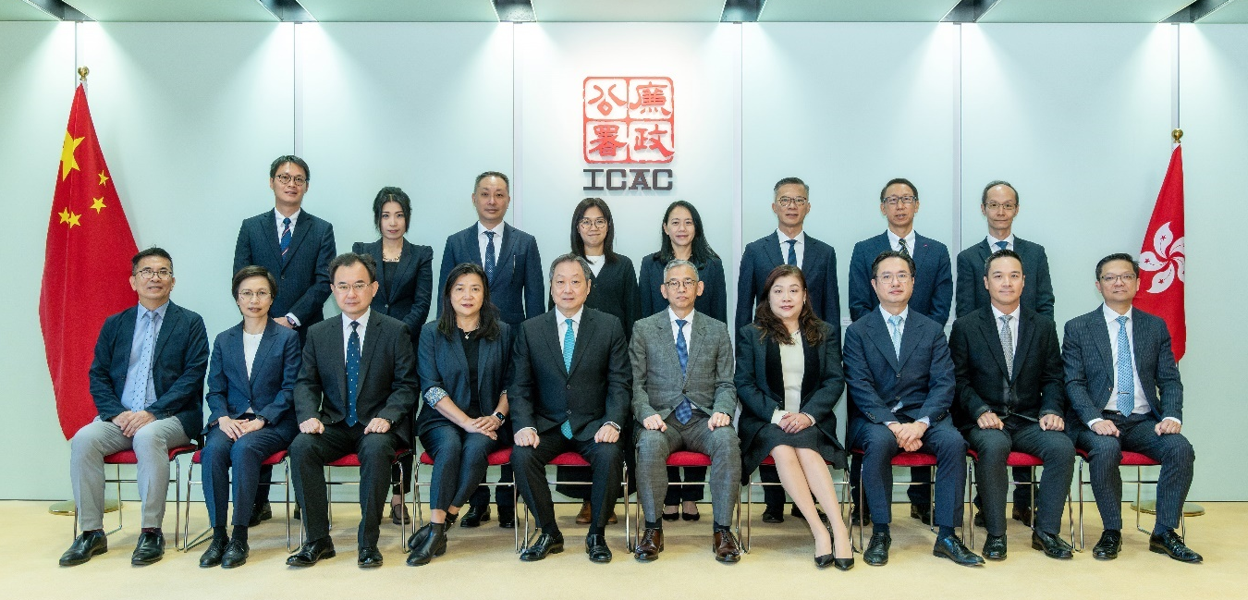

Dr Kelvin WONG Tin-yau, SBS, JP | (Chairman)
Mr Stephen CHAN Man, JP
Miss Mabel CHAN Mei-bo, JP
Mr William Junior Guilherme DOO, BBS, JP
Ms Amelia FOK Ching-yin
Ms Cindi HUI Ming-ming, MH
The Hon Doreen KONG Yuk-foon
Ms Carrie LAU Ka-wai
Mr Jonathan LEE Man-kwong
Mr Rex MOK Chung-fai, BBS, MH, JP
Mr Hendrick SIN, MH, JP
Mr Albert SU Yau-on, MH, JP
Commissioner of Police or representative | (ex officio)
Director of Administration or representative | (ex officio)
Commissioner, Independent Commission Against Corruption | (ex officio)

Annex C ASSIGNMENT STUDIES COMPLETED BY CORRUPTION PREVENTION DEPARTMENT IN 2025

Organisation |  | Subject Area
- Government Bureaux/Departments
Buildings Department |  | Control of Minor Works
Construction Industry |  | Digital Payment System and Digital Contract Administration System for New Engineering Contracts
Customs and Excise Department |  | Administration and Enforcement of Licensing Regime for Money Service Operators
Development Bureau |  | Corruption Prevention Work on Framework Contract and Alliance Contract
Drainage Services Department |  | Administration of New Engineering Contract Term Service Contracts for Maintenance Works of Sewage Treatment Facilities
Education Bureau |  | Operation of the Hong Kong Academy for Gifted Education
Electrical and Mechanical Services Department |  | Procurement and Administration of Minor Maintenance Works
 |  | Registration and Regulation of Electrical Contractors and Workers
Environment and Ecology Bureau |  | Administration of Green Tech Fund
Fire Services Department |  | Control of Fire Service Installations and Equipment and Fire Safety Products
Food and Environmental Hygiene Department |  | Control of Imported Food by Air
Government Logistics Department |  | Procurement of General Government Vehicles
Government Property Agency |  | Letting and Administration of the Management, Operation and Maintenance Contracts at Boundary Control Points
Highways Department |  | Quality Control of Tunnelling Works
Home Affairs Department |  | Community Involvement Programme
Hongkong Post |  | Retail Operations at Post Offices
Hong Kong Monetary Authority |  | Complaint Handling Procedures
 |  | Enforcement of the Anti-Money Laundering and Counter-Terrorist Financing Ordinance
Hong Kong Police Force |  | Handling of Case Properties
Housing Bureau |  | Corruption Prevention Work on Basic Housing Units
 |  | Corruption Prevention Work on Light Public Housing
Housing Department |  | Control of Unauthorised Building Works
Independent Commission Against Corruption |  | “Coding4Integrity Asian Youth Anti-Corruption Hackathon” – A Showcase of InTECHgrity x Youth x International Cooperation
Information Services Department |  | Procurement of Publicity Services
Inland Revenue Department |  | Control of Access to Taxpayers’ Information
Innovation and Technology Commission |  | Administration of New Industrialisation Funding Scheme
Innovation and Technology Sector |  | Corruption Prevention Guide on Funding Schemes on Innovation and Technology
Labour Department |  | Certification Regime of Construction Machine Operators
Lands Department |  | Compensation Arrangements in Land Resumption
Marine Department |  | Construction of Government Vessels
Planning Department |  | Plan Making and Processing of Planning Applications (Part I)
Public Sector |  | InTECHgrity Framework
 |  | Research on Integrity Risk Assessment Framework for the Public Sector
Radio Television Hong Kong |  | Administration of Community Involvement Broadcasting Service
Rating and Valuation Department |  | Enforcement of Tenancy Control on Subdivided Units
Social Welfare Department |  | Administration of Comprehensive Social Security Assistance Scheme
Transport Department |  | Monitoring of Franchised Bus Services
 |  | Operation and Monitoring of Designated Car Testing Centres

- Scheduled Public Bodies
Organisation |  | Subject Area
Accounting and Financial Reporting Council |  | Oversight of Hong Kong Institute of Certified Public Accountants’ Performance of its Statutory Functions
CLP Power Hong Kong Limited |  | Administration of Eco Building Fund
Construction Industry Council |  | Administration of Training Programme
Hong Kong Arts Development Council |  | Organisation and Management of the Hong Kong Performing Arts Expo
Hong Kong Examinations and Assessment Authority |  | Development and Security of Question Papers of the Hong Kong Diploma of Secondary Education Examination
Hong Kong Science and Technology Parks Corporation |  | Admission of Tenants of Science Park and InnoCentre
Hong Kong Sports Institute Limited |  | Administration of Training Programmes for Elite Sports
Hong Kong Tourism Board |  | Administration of the Pilot Scheme for Characteristic Local Tourism Events
Hospital Authority |  | Procurement and Maintenance of Medical Equipment
Insurance Authority |  | Supervision on Anti-Money Laundering and Counter-Terrorist Financing Related Matters of Insurance Institutions
Property Management Services Authority |  | Licensing and Control of Property Management Companies and Property Management Practitioners
Securities and Futures Commission |  | Handling of Conflict of Interest and Confidential Information
Tertiary Education Institutions (TEIs) |  | Corruption Prevention Guide on Admission of Students for TEIs
The Hong Kong Academy for Performing Arts |  | Administration of Study Programmes of Extension and Continuing Education for Life
The Hong Kong Polytechnic University |  | Funding Schemes for Entrepreneurship
The Hong Kong University of Science and Technology |  | Management of Research Projects
Travel Industry Authority |  | Procurement Procedures

- Others
Organisation |  | Subject Area
Building Management Sector |  | Review of Corruption Prevention Strategy in Building Management (Vol.1 – An Introductory Overview)
Construction Industry |  | Research on Project Integrity Management Framework –Procedural Risk Management
 |  | Research on Project Integrity Management Framework – Project Oversight Architecture
 |  | Research on Project Integrity Management Framework – Stakeholder Integrity Building
Hong Kong-Shenzhen Innovation and Technology Park Limited |  | Operation of Hong Kong-Shenzhen Innovation and Technology Park
Private Sector |  | Corruption Prevention Guide on Doing Business with Integrity in the Greater Bay Area
 |  | Leveraging the “Banking Industry Integrity Charter” for a Sustainable Corruption Prevention Strategy in the Banking Sector
 |  | Practical Guide on Integrity Compliance Management System
 |  | Research on Integrity Capacity and Culture Building for Corporations
 |  | Research on Integrity Compliance Management System Audit for Corporations
 |  | Research on Integrity Risk Management for Corporations
The Football Association of Hong Kong, China Limited |  | Organisation and Monitoring of Matches

Citizens Advisory Committee on Community Relations

CITIZENS ADVISORY COMMITTEE ON COMMUNITY RELATIONS

ANNUAL REPORT 2025
TO THE CHIEF EXECUTIVE

The Chief Executive the Honourable
Mr John LEE Ka-chiu,

TERMS OF REFERENCE AND MEMBERSHIP
The Citizens Advisory Committee on Community Relations (CACCR), comprising 16 non-official members and one official member, advises the Commissioner of the ICAC on the Commission’s work to foster public support in combating corruption and educate the public against the evils of corruption. Its terms of reference and membership are at Annexes A and B respectively. Prof Joshua MOK Ka-ho retired from the Committee at the end of 2025 whilst Dr Kalwan KWAN Ming-tak joined the Committee as a new member in 2026.

WORK OF THE COMMITTEE
During the year, the CACCR conducted four meetings to discuss and advise on ICAC’s integrity education and publicity work. In particular, the CACCR discussed the ICAC’s education and publicity strategies in 2025/26, the results of ICAC Annual Survey 2024, the work plan for Safeguarding Clean Legislative Council General Election, as well as the work of ICAC on youth integrity and preventive education. CACCR members also participated in 18 preventive education activities, reviewing the effectiveness of the activities and providing feedback from a first-hand perspective.

REVIEW OF EDUCATION AND PUBLICITY WORK IN 2025
In 2025, the Community Relations Department (CRD) continued to gauge the pulse of the society and strive for innovation. On the one hand, innovative publicity strategies were adopted, integrating creative means with cutting-edge technology to continuously enhance the appeal and coverage of publicity messages. On the other hand, they also focused on various sectors and key groups of the society to strengthen preventive education through immersive programmes and interactive experiential projects, fostering the culture of probity in Hong Kong. On behalf of the Committee, I would like to report on the achievements of the ICAC during the year.
Continuously Innovating Publicity Strategies
Café “1974” and ICAC Exhibition Hall
The Committee was pleased to note that the ICAC continued to innovate by integrating digital technology and immersive experiences to organise various public engagement activities, successfully attracting both general public and tourists. These initiatives included the opening of Café “1974”, allowing the general public to understand Hong Kong’s anti-corruption history and the work of ICAC. In addition to launching thematic activities, the ICAC marked the first collaboration with the arts sector by hosting an ink wash painting exhibition with a renowned artist in the Café. Through the infusion of integrity messages into the exhibits, Café “1974” was successfully transformed into a diversified platform for promoting the ICAC's anti-corruption work. Since its opening, the Café has attracted over 190 000 visits, achieving extensive publicity effect.

Furthermore, the ICAC completed a revamp of its exhibition hall in May 2025, incorporating a host of innovative technologies and showcase of advanced exhibition techniques to provide a refreshing and immersive experience for visitors. Upon its re-opening, it welcomed over 50 000 visitors, about 80% of whom were tourists, demonstrating the ICAC’s cross-regional appeal. To tie in with the HKSAR Government’s “Tourism is Everywhere” policy, the ICAC Exhibition Hall and Café “1974” were included as one of the spots of the “Disciplinary Services Pioneer Tours”. The ICAC also actively collaborated with the tourism industry to incorporate the ICAC into their regular tour itineraries.

The Committee fully endorsed ICAC’s innovative approach to publicity and education, which successfully integrated the ICAC Exhibition Hall and Café “1974” seamlessly. Through highly creative approach, the ICAC encouraged the public to proactively step into the ICAC to gain an in-depth understanding of Hong Kong’s anti-corruption history.
Media Publicity
In terms of media publicity, the Committee was pleased to see that the ICAC, adopting a strategy of "low cost and high effectiveness", flexibly deployed artificial intelligence (AI) technology to produce in-house creative and educational short videos with anti-corruption messages for distribution on various social media platforms. Multiple short film series had attracted tens of thousands to millions of views online, achieving highly encouraging results. Three of the promotional videos clinched a total of 14 accolades in prestigious international video competitions, demonstrating a high level of international recognition for ICAC’s work. The videos also served as an important medium for promoting Hong Kong's culture of probity overseas.

Leveraging Social Media and International Platforms
The CACCR commended the ICAC for paying close attention to the changing habits of the public in receiving public information and widely promoting anti-corruption messages on various social media platforms based on the preferences of different audiences, further broadening its media outreach. Meanwhile, the ICAC also actively deepened cooperation with anti-corruption agencies and international organisations through a variety of international platforms, sharing and exchanging the time-tested strategy of anti-corruption education and successful cases of Hong Kong. The ICAC also focused on strengthening its international publicity efforts, consolidating its leading role in the global anti-corruption arena and enhancing Hong Kong’s reputation as a city of integrity.

“Operation 303”
During the year, the ICAC launched an innovative and brand-new experiential investigation activity, namely “Operation 303”, inviting participants to play the role of ICAC investigators and take part in the simulated investigation of a major corruption case in the ICAC Building. Through realistic scenarios such as evidence collection, arrest and interview with suspects, participants gained first-hand experience of the challenges in corruption investigation as well as the professionalism and perseverance of ICAC officers. The activity received overwhelming responses and garnered positive feedback from participants. The CACCR fully affirmed this innovative and experiential activity, which not only broke through the limitations of conventional education by allowing the general public to internalise anti-corruption messages through an immersive experience, but also successfully pioneered a new direction for integrity education and publicity initiatives.

Strengthening preventive education for major targets
In addition to continuous innovation in publicity strategies, the Committee also acknowledged the ICAC’s ongoing “Ethics for All” approach to tailor preventive education programmes for various sectors of the community.
Promoting Building Management and Maintenance
Building management and maintenance has always been an issue of public concern involving many stakeholders. As such, the ICAC has been engaging with building management bodies, district governance teams and flat owners through channels such as visits, seminars, workshops and integrity training to explain to them the anti-corruption laws and common corruption risks, while encouraging owners’ corporations to enhance transparency and strengthen communication with flat owners. The ICAC also maintains a building management enquiry hotline and a thematic website to provide the public with the latest information and timely assistance. At the same time, the ICAC continues to provide online and offline training for property management practitioners and disseminate e-newsletters through the “Integrity Property Management League” to sustain their awareness of integrity issues.

In June 2025 the ICAC took the lead in hosting the first-ever territory-wide Building Management Summit in collaboration with relevant government departments, regulatory bodies, professional bodies and District Councils of all 18 districts, gathering over 300 representatives from host departments/organisations, property management professionals and owners’ corporations for practical exchanges and experience sharing. The event served as an effective platform for learning and exchange among various stakeholders, consolidating efforts across different sectors to jointly tackle issues relating to building management and maintenance. The Committee was in full support of ICAC’s efforts in deepening the collaboration with flat owners and various stakeholders; strengthening preventive education and ethics promotion on building management and maintenance; and providing timely assistance to the public.
Enhancing Moral Education for Youth
The Committee highly commended that the ICAC has consistently been organising a variety of integrity promotion programmes for youths at different developmental stages, nurturing the next generation into responsible citizens who uphold the core values of rule of law and integrity. In particular, the ICAC launched the new Little Coffee Bean Kids Theatre for kindergartens, featuring an original cartoon character Little Coffee Bean as the protagonist of the interactive puppet show, encouraging children to learn the virtue of honesty. Around 3 500 students, teachers and parents from over 100 kindergartens visited the ICAC Building for the show. In response to the overwhelming enrolment, additional public shows were staged at the Hong Kong Cultural Centre, achieving highly satisfactory results. In addition, the ICAC launched new moral education picture books featuring Little Coffee Bean, enabling kindergarten and junior primary students to learn proper values through reading with teachers and parents. At the same time, the ICAC actively developed teaching packages, activity materials and other moral education resources in alignment with school curriculum to support teachers to promote values education in schools.

On the other hand, to actively promote youth engagement in anti-corruption initiatives, the ICAC launched two international capacity building programmes in Brunei Darussalam and Thailand respectively, sharing experiences with anti-corruption and law enforcement agencies of the Association of Southeast Asian Nations on youth participation in anti-corruption work. Local university students from the ICAC ELITE Youth Leadership Programme also attended the programmes to share the importance and impact of youth participation in integrity promotion on the international stage.
Safeguarding Clean Elections
The ICAC adopted an “All-embracing” education and publicity strategy to ensure the 8th Legislative Council General Election was conducted in a fair, open and honest manner. A series of activities were rolled out for various stakeholders, including over 200 briefings on the electoral laws for candidates, election helpers and electors. Reference materials were also produced for the relevant targets. At the same time, a combination of online and offline publicity channels including public transport network, government facilities in 18 districts, popular websites, social media platforms and mobile applications as well as outdoor LED walls were fully deployed to publicise clean election messages. An AI-generated animation video was also debuted to call on general public to support clean election and cast their votes.
Fostering Probity Culture in Public and Private Sectors
The Committee is in full support of ICAC’s ongoing partnership with the Civil Service Bureau in implementing the Ethical Leadership Programme. During the year, the ICAC offered preventive education resources to government bureaux/departments and organised thematic workshops, delving into topics including Misconduct in Public Office and how to leverage digitalisation to enhance supervisory duties. At the same time, the ICAC actively encouraged public bodies in adopting the ICAC’s diversified anti-corruption services and educational resources, and continued to conduct integrity training seminars for their staff.

In the private sector, a clean level-playing field for business is an important cornerstone for consolidating Hong Kong's status as an international financial centre and enhancing its competitiveness. The CACCR commended the Hong Kong Business Ethics Development Centre (the Centre) under the ICAC for significantly increasing the quantity and variety of webinars to meet the training needs of business corporates. At the same time, the membership of the Centre’s Advisory Committee was expanded from 10 to 19 chambers of commerce. The ICAC would strengthen its connection and collaboration with international chambers of commerce in Hong Kong via this platform to demonstrate ICAC’s commitment in combating corruption and safeguarding a clean level-playing field. By leveraging on member chambers’ network, relevant messages could be disseminated to overseas companies with a view to attracting inward investment in Hong Kong.
Reaching out to Imported Workers and Incoming Talents
Since the Government enhanced the mechanisms for importing talents and workers in 2023, the ICAC has been offering briefings on anti-corruption laws and distributing information packs to all imported workers. The ICAC has also been visiting quarters or work sites of the workers to meet them face-to-face and urge them to reject any solicitation of bribes and report such to the ICAC. Furthermore, the ICAC is incorporating simple and direct anti-corruption messages into the daily work and living environment of imported workers, such as sharing e-posters in their WeChat groups to maximise publicity.

The Committee was also pleased to note that the ICAC maintained close collaboration with the Hong Kong Talent Engage and other talent services organisations to promote Hong Kong’s probity and integrity culture to incoming talents through organising ICAC visits, hosting sharing sessions and promoting anti-corruption messages in talent exhibitions. During the year, the ICAC once again participated in the talent summits to introduce Hong Kong’s edge of probity and anti-corruption initiatives to talents from the Mainland and overseas, as well as those planning to start businesses in Hong Kong. The ICAC also continues to leverage social media platforms such as WeChat, Weibo and Xiaohongshu to disseminate short videos and easy-to-understand messages that highlight the key points of the anti-corruption laws for incoming talents.

CONCLUSION
Past ICAC Annual Surveys consistently reflected that the society of Hong Kong firmly supported the anti-corruption cause. The general public showed zero tolerance towards corruption and believed that maintaining a clean society was crucial for Hong Kong’s overall development. The CACCR fully recognised ICAC’s effort in adopting innovative publicity strategies and deepening preventive education in 2025, thereby continuously strengthening Hong Kong's probity culture. CRD had demonstrated a high level of professionalism with an innovative mindset, from creating a landmark for immersive integrity education, producing internationally acclaimed short films to conducting tailored preventive education initiatives in the community. Looking ahead, the CACCR fully supports the ICAC in continuously innovating its publicity and education strategies to uphold Hong Kong's core values of integrity.

APPRECIATION
I would like to extend my sincere thanks to all members of the Committee for their contributions and full support throughout the year. I also treasured the opportunity of working together with members from multiple professional fields as well as young members who joined the Committee through the Member Self-recommendation Scheme for Youth to sustain the probity culture of Hong Kong.
The Committee also appreciated ICAC officers for continuously collaborating with the entire community to combat corruption and promote integrity, infusing professional and innovative approaches into various projects and striving hard to maintain Hong Kong’s integrity culture.

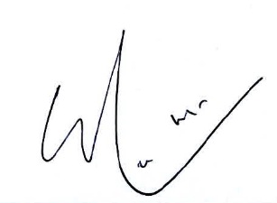

Simon HO Shun-man
Chairman
Citizens Advisory Committee on Community Relations

Annex A CITIZENS ADVISORY COMMITTEE ON COMMUNITY RELATIONS
TERMS OF REFERENCE (as at 31 December 2025)

- To advise the Commissioner of the Independent Commission Against Corruption measures to be taken to foster public support in combating corruption and educate the public against the evils of corruption.

- To receive and call for reports on action taken by the Community Relations Department of the Commission in pursuance of the above.

- To monitor community response to the Commission’s work and public attitudes towards corruption in general.

Annex B CITIZENS ADVISORY COMMITTEE ON COMMUNITY RELATIONS
MEMBERSHIP (as at 31 December 2025)

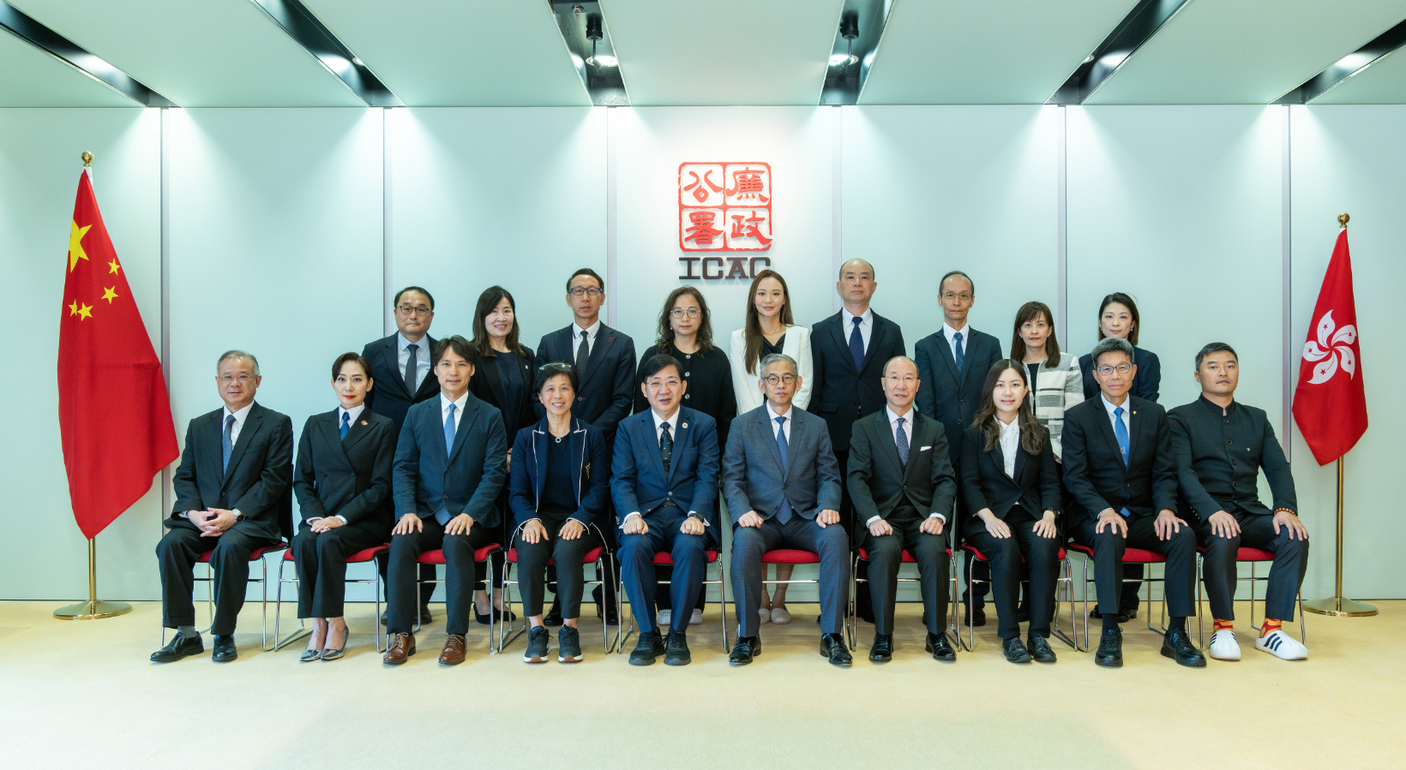
Prof Simon HO Shun-man | (Chairman)
Ms Amy CHAN Lim-chee, BBS, JP
Ms May CHAN Suk-mei, GBS, JP
Dr Albert CHAU Wai-lap
Ms Cally KWONG Mei-wan, JP
Ms Pinky LAU Pik-yiu
Mr Bosco LAW Ching-kit, JP
Mr Armstrong LEE Hon-cheung
Dr Bobby LIU Kam-hing, MH
Ms Gloria MAK Sze-man
Prof Joshua MOK Ka-ho
Mr Kazaf TAM Chun-kwok, BBS, JP
Ms Kelly TSIM Ka-lee
Mr Andy WAN Ka-kit
Dr James WONG Kong-tin, BBS, JP
Ms Jenny YUNG Ching-yi
Commissioner, Independent Commission  Against Corruption | (ex officio)

Unless otherwise specified, the figures on complaints and cases mentioned in this document are unrelated to the Elections (Corrupt and Illegal Conduct) Ordinance (Cap 554).
*Statistics exclude the numbers of corruption prevention talks conducted.

